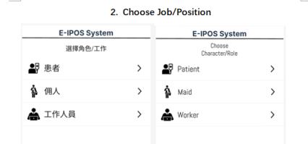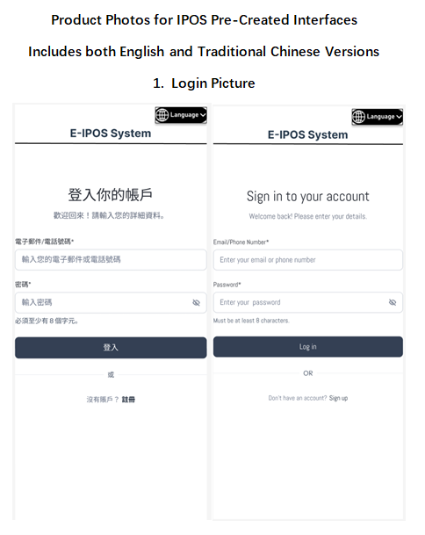

**Comments:**

**1) login methods: add fingerprint & face ID**

**2) use patient ID# instead of email/tel# as username**

**3) add “reset password”**

**4) incorporate page 2**

**into page 1 in the form**

**of a drop down menu**

**at the bottom of page 1**

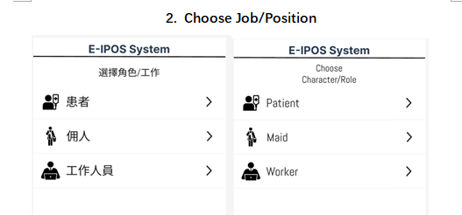

**Comments:**

**this page is to be incorporated into page 1.**

**item names revised as below:**

**選擇身分 / Select Your Role**

**2nd role as “家庭照顧者 / Caregiver”**

**3rd role as “家佣 / Domestic Helper”**

**4th role as “醫務人員 / Health Care Worker”**

**Add below 2 icons on each page for easy navigation:**





**sample 1**

**with reference to sample 1, add a “Homepage” on which 5 items can be selected by users:**

**1) About the Study / 關於研究**

**2) Personal Information / 個人資料**

**2.1: 姓名, 2.2: 電話號碼, 2.3: 身分:患者/家庭照顧者/家佣/醫務人員, 2.4:主要癌症部位**

**3) Questionnaire /問卷**

**3.1: Section 1: Open End Question’**

**3.2: Section 2: physical symptom ranking**

**3.3: Section 3: psychological symptom ranking**

**3.4: Section 4: Way of Completing the Questionnaire**

**4) View the Report**

**5) Setting (ref to sample 2 & 3)**

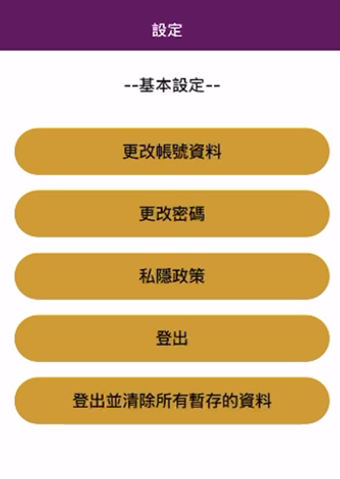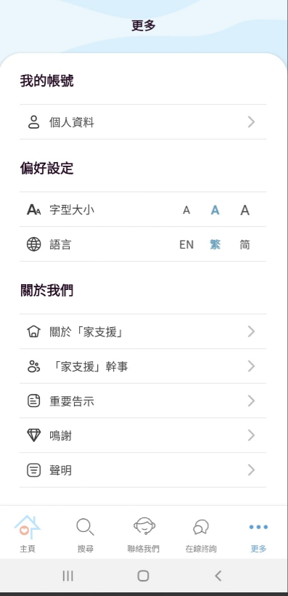

**sample 3**

**sample 2**

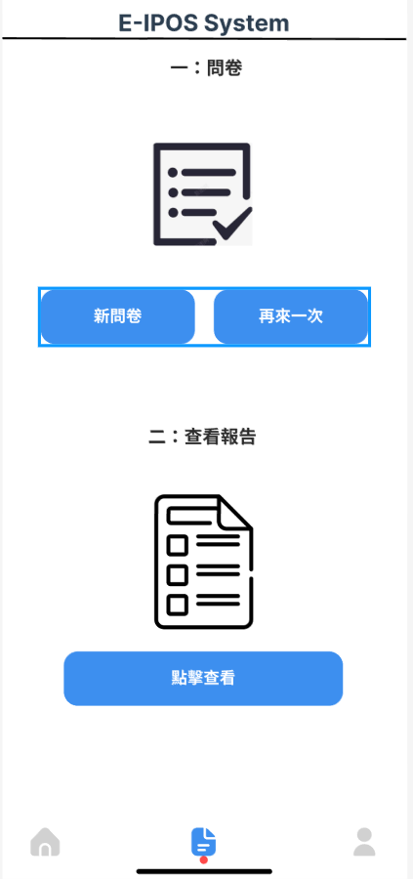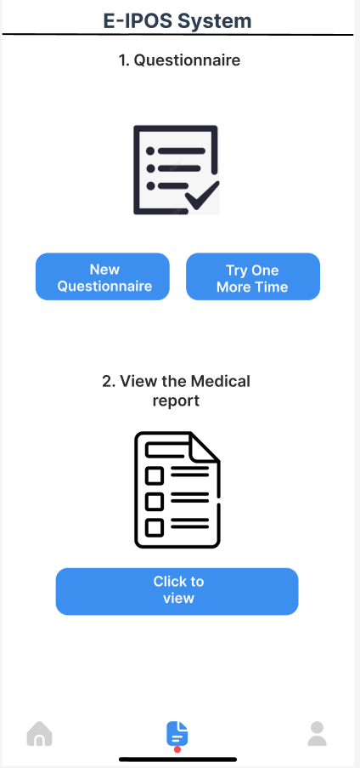

Explanation:

The Questionnaire page offers two primary functions:

1. Questionnaire: Users can begin a new questionnaire or retake one to assess their health status.
2. Medical Report: Users can view their medical report if they have completed the questionnaire.
3. **Questionnaire Based Feedback Test**

* **Open End Questions**

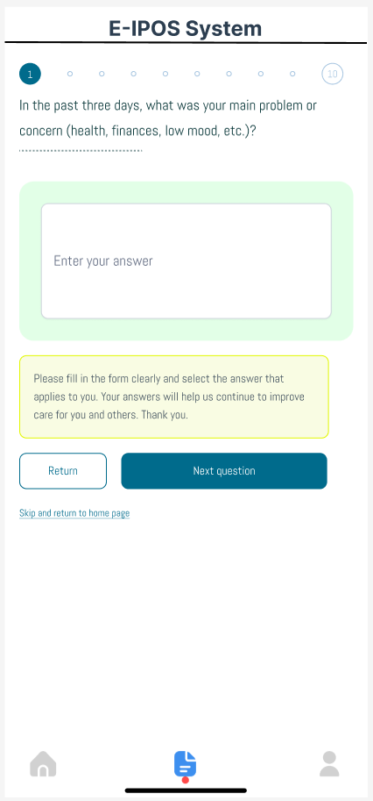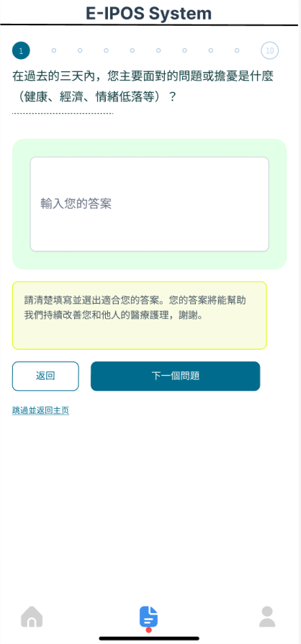

Explanation:

This page of the E-IPOS System presents a questionnaire, prompting users to describe their main problem or concern from the past three days using a open end question. Users can enter their answers, navigate to the next question, or return to the home page.

* **Ranking Questions**

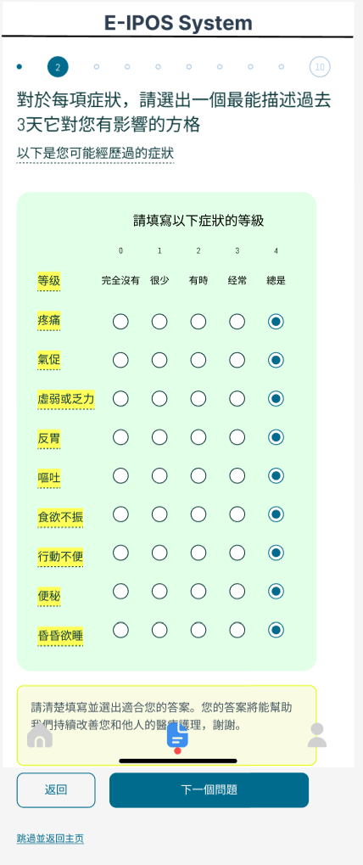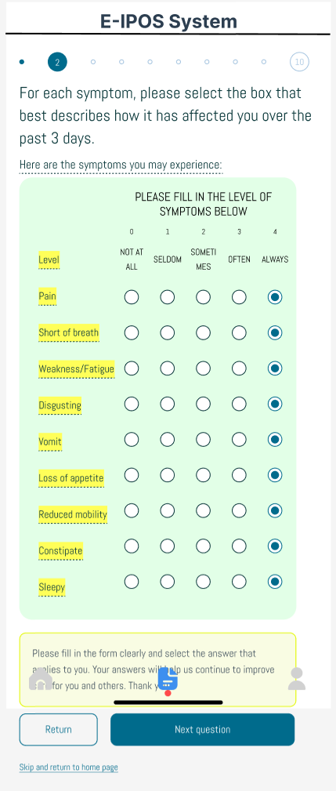

Explanation:

This page presents a questionnaire asking users to rate the impact of various symptoms experienced in the past three days through a ranking question. Users select levels for each symptom, then can proceed to the next question or return to the home page.

The picture can be scrolled down when using in phone app.

* **MC Questions**

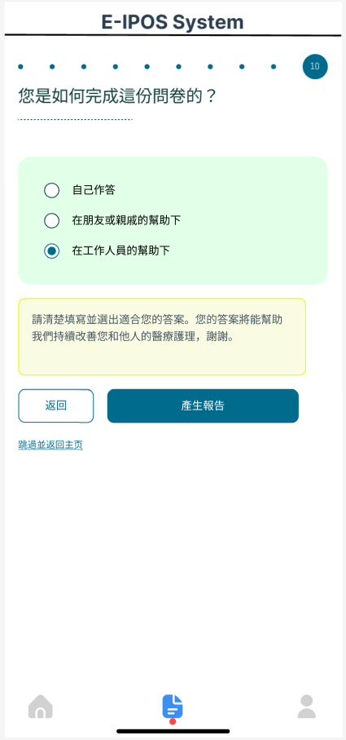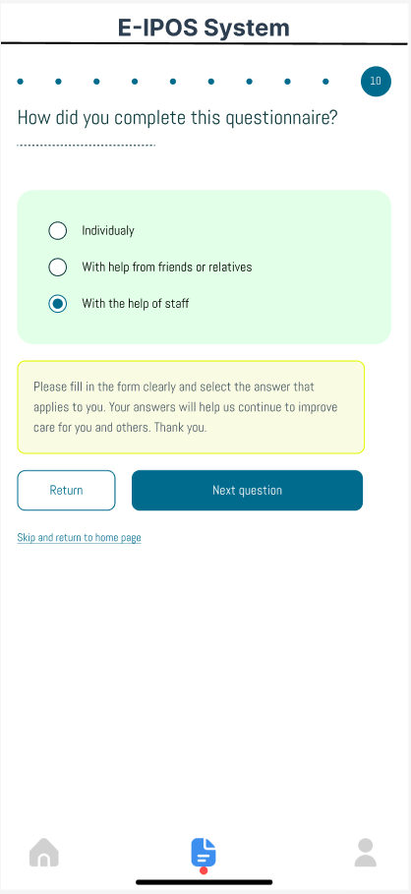

Explanation:

This page asks users how they completed the questionnaire, offering options like "Individually" or "With help from staff" through a MC question. Users can select an option, return to the previous page, or proceed to the next question.

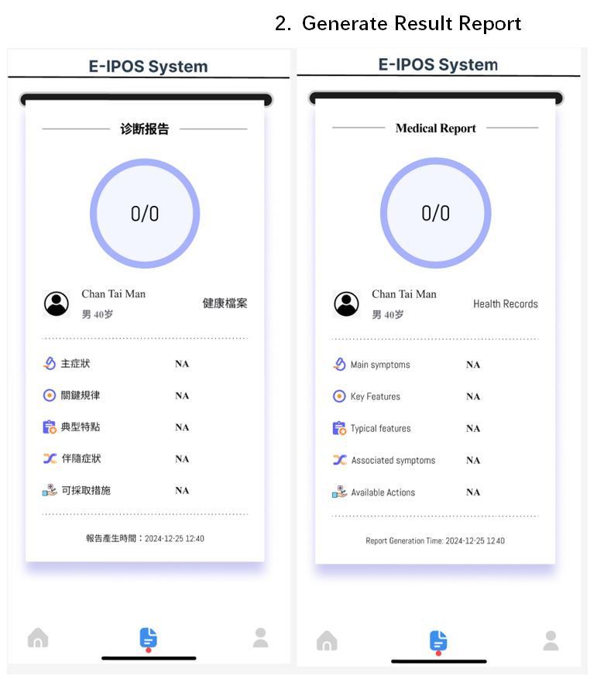

**Change the form of report from grades to histograms like below showing the trends in symptom scores**

**:**

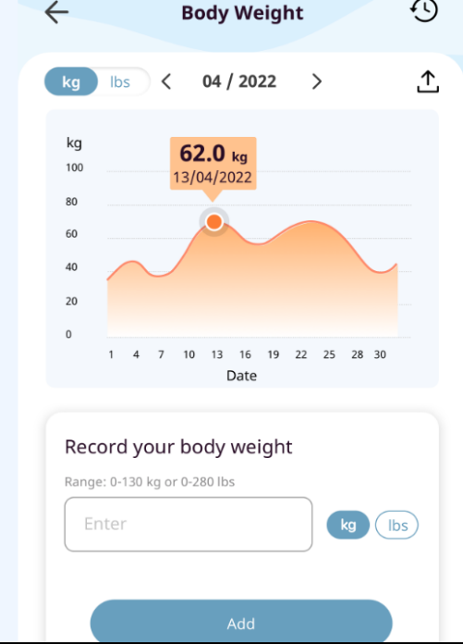

.**Health Carer Interface for Workers**

* **Mobile App Version**

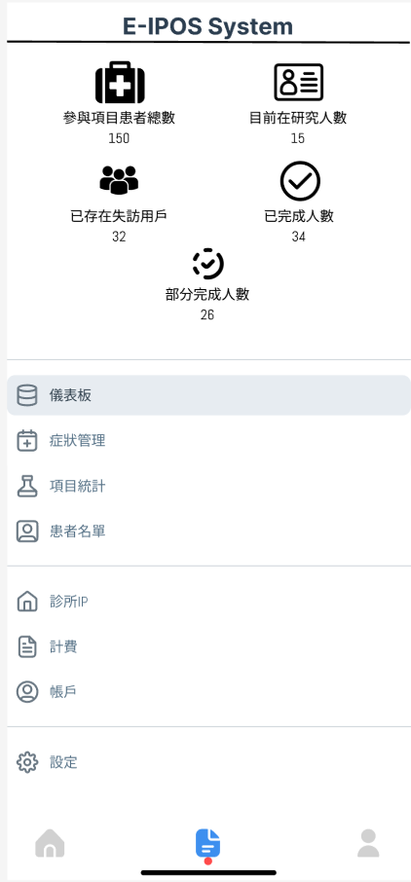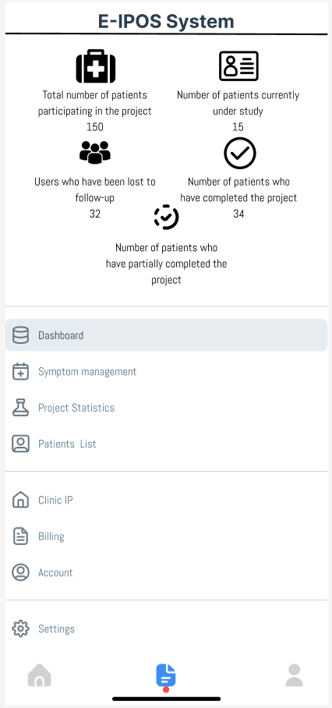

Explanation:

This page is an example page of the app version for the E-IPOS System that display project summary and statistics, including total participants, patients currently under study, and numbers of users lost to follow-up and those who have completed the project. Navigation options for symptom management and patient lists are also provided. These functions are for the care workers or workers at the hospital so they can see the performance of the patients on the questionnaires and contact them if serious symptoms have appeared.

* **Web Interface Version**

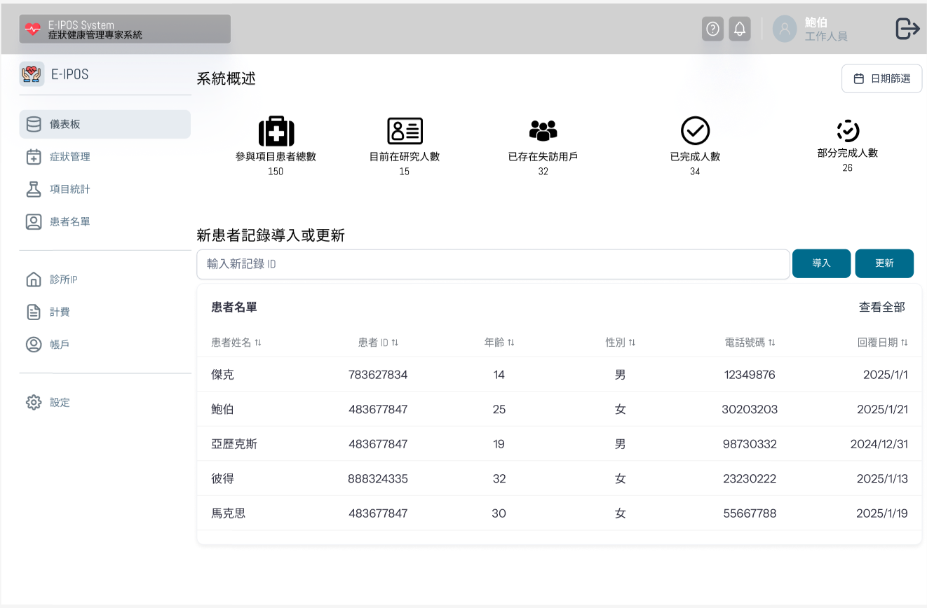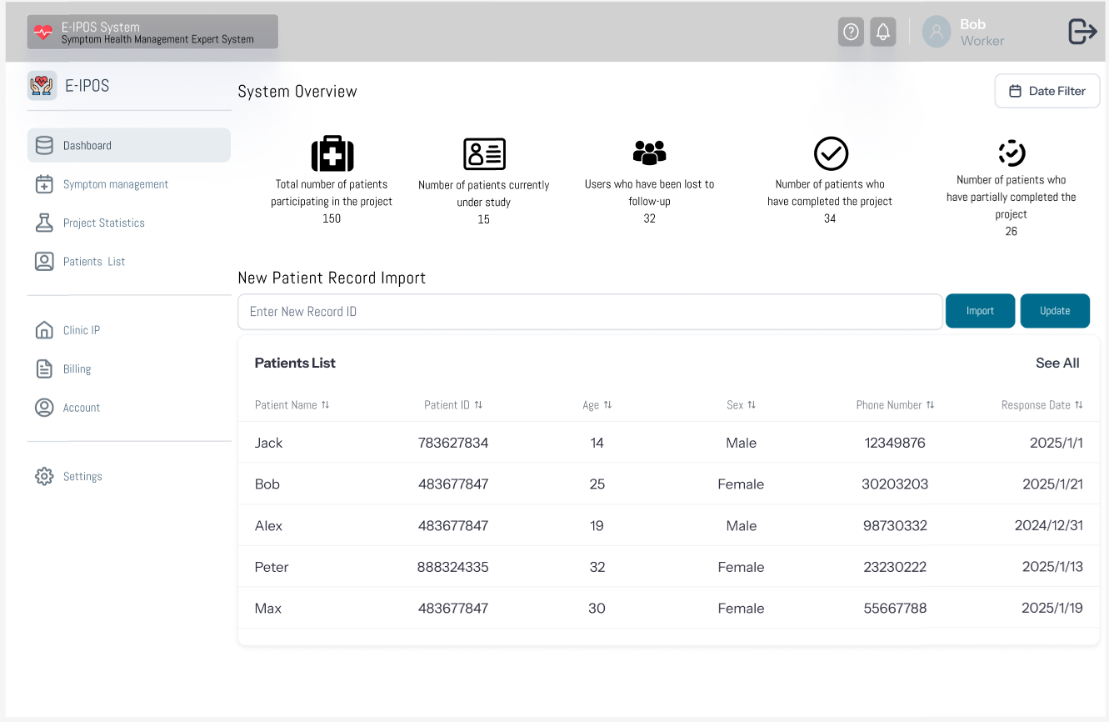

**Comments:**

**add “第幾次填寫” & “填寫人身分”**

**Can the content in page 9 & 10 be shown in the same App? Or another new platform needed**

**One more missing: for each score, advice needed. Can you create a new page as well?**

Explanation:

This page is an example page for the web interface version that displays an overview of the E-IPOS system, showcasing patient participation statistics, a list of patients with their details (ID, age, gender, and registration date), and options to import or update patient records for project management. These functions are for the care workers or workers at the hospital so they can see the performance of the patients on the questionnaires and contact them if serious symptoms have appeared.